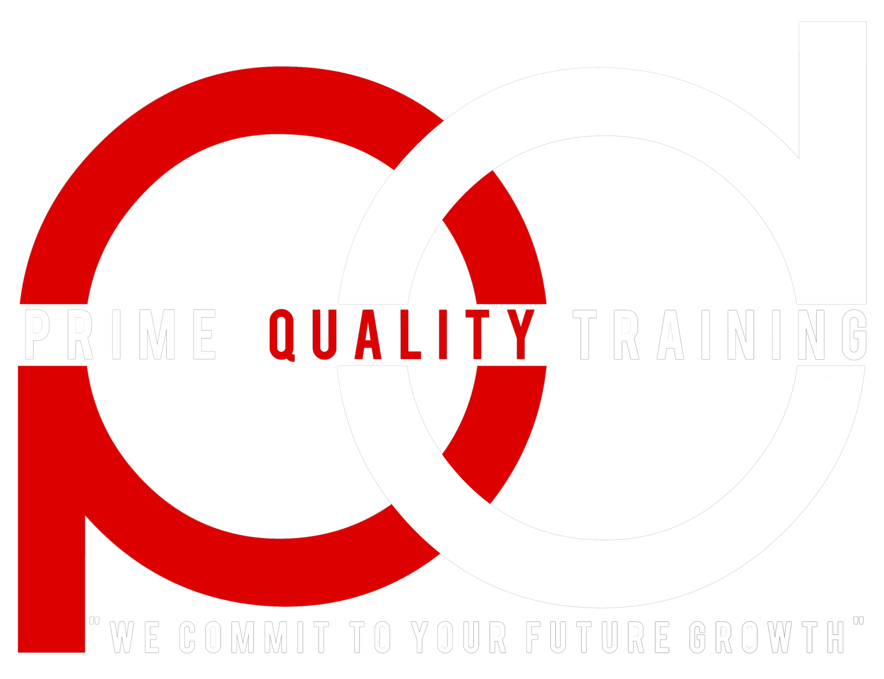

To:

**Fasika Merkebe**

**Ethiopian Commidity Exchange**

**Al-SamTower2, 3rdFloor, Lideta Addis Ababa, Ethiopia**

From: **Prime Quality Training Singapore (PQSG)**

8 Boon Lay Way #06 -11 Trade Hub 21,

Singapore 609964

CC:

**Mr. Abiy Wasiyhun, Mr. Mehateme Kebede**

Page: 3 Date: 16th August, 2016

**SUBJECT: In House Training Proposal**

Dear Sir/Madam

We are very pleased to provide the required information as following details

**1. Detailed firm profile**

* Date of Establishment

​Singapore office was created on 09/09/2011

* Vision and mission

The Training Division at PQ produces high quality, industry specific Corporate Trainings, Executive Masterclasses, Technical Seminars and Practical Workshops.

• Extensive Research

• Careful Trainer Selection

• Cutting Edge Course Content

• Top Class Venues

We provide unique incentive and exceptional opportunities for professionals participating in Prime Quality Training to gain knowledge, find practical solutions and effectively network with industry peers.

Prime Quality Training creates critical business connections & giving solutions to business partners by the most practical international training courses. Development strategy of Prime Quality Training aims to develop knowledge to global corporate clients.

With a team of leading professors from top developed countries such as US, UK, Australia, … as well as diverse courses in various fields of Finance, Energy, Telecom & IT, Retail, Marketing, Human Resources , Infrastructure, Mining, Real Estate, Aviation, Military, ... Prime Quality Training has been providing clients with knowledge, solution, partnerships and market insights to continuously adapt and keep pace.

* Area of focus

We provide business intelligence, international training around the world with topic related to Human Resources, Technical, Procurement and many others.​

* List of clients (firms/organizations) globally
* Ghana Ministry of Finance
* Kenya Public Service Commission
* Kenya Parliamentary Service
* Kenya Water Resource Management Authority
* Tanzania Airport Authority
* Zimbabwe Power Corporation
* Zambia Zambezi River Authority
* Chevron
* Shell
* B&W Offshore
* and many more

​

* List of clients (firms/organizations) in Ethiopia (Name and contact address) and type of engagement (describe specific training or consultancy type)
* **Messebo Cement** (Safety Training and Technical Training)
* **Dilla University** (Transformational Leadership Training
* **Samara University** ​(Transformational Leadership Training)​
* **M​inistry of Agriculture** (Transformational Leadership Training)
* **Horra Trading Public College of Oromia** (Transformational Leadership Training)
* **Saya Breweries** (Transformational Leadership Training)​

**Please note that the contacts provided only upon permission of clients, so we cannot provide now.**

* Firms experience in leadership development and related development areas

​We provide all kind of leadership and organizational development and other HR related training.

**2. Trainer/Facilitator(s) profile**

* Facilitators qualification;
* Practical work experiences in leadership role in competitive global organization;
* Executive and middle management Leadership development training program delivery experience;
* Certification on the subject or related;
* Other relevant information.

Kindly find attached 3 sample course outlines. The contents of those documents will explain trainer/facilitator(s) profile in detail related to all the points above and the course agenda. If you need any further clarification or more specific information regarding any particular aspects, please don't hesitate to get in touch me and I will furnish you with more details from our production department.

* Transformational Leadership and Change Management (3 days)
* International Certificate in Transformational Leadership and Change Management (Certified by an United Kingdom Government authorized body) (5 days) (in Kenya and Ethiopia)